**Multiple and Multilevel Inheritance**

**LAB #** **06**

**Object Oriented Programming Fall 2020**

Submitted by: **Wisal Mukhtiar**

Registration No.: **19PWCSE1756**

Class Section: **B**

“On my honor, as student of University of Engineering and Technology, I have neither given nor received unauthorized assistance on this academic work.”

Submitted to:

**Engr. Sumayyea Salahuddin**

Date : January, 13, 2020

Department of Computer Systems Engineering

University of Engineering and Technology, Peshawar

**Objectives of the Lab:**

Objectives of the lab are to:

# Understand the concept of multiple and multilevel inheritance.

# Write two level inherited classes.

* Write a class inherited from multiple base classes.
* Write multi-file programs covering inheritance.

# Activity # 01

**Title:**

Make a Parent class for First, inherit class Second from First and class Third from Second.

**IN C++**

**SOURCE CODE:**

#include <iostream>

using namespace std;

class First

{

protected:

int f;

public:

void f_input()

{

cout<<"Enter value of f: ";

cin>>f;

}

};

class Second: public First

{

protected:

int s;

public:

void s_input()

{

f_input();

cout<<"Enter value of s: ";

cin>>s;

}

};

class Third: public Second

{

protected:

int t;

public:

void t_input()

{

s_input();

cout<<"Enter value of t: ";

cin>>t;

}

void Max()

{

if(f>s && f>t)

cout<<"Max: "<<f<<endl;

else if (s>f && s>t)

cout<<"Max: "<<s<<endl;

else if (t>f && t>s)

cout<<"Max: "<<t<<endl;

}

void Show()

{

cout<<"f: "<<f<<endl;

cout<<"s: "<<s<<endl;

cout<<"t: "<<t<<endl;

}

};

int main()

{

Third t1;

t1.t_input();

t1.Show();

t1.Max();

return 0;

}

**OBSERVATION (TESTING & DEBUGING):**

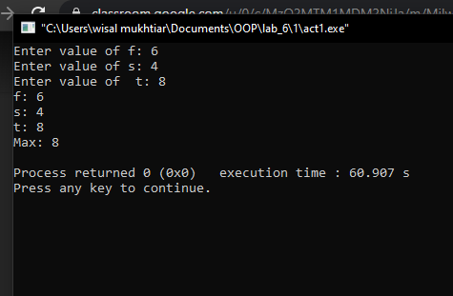

**In Python**

**Source code:**

class First:

    f = 0

    @classmethod

    def input_f(cls):

        First.f = float(input("Enter f :"))

class Second (First):

    s = 0

    @classmethod

    def input_s(cls):

        First.input_f()

        Second.s = float(input("Enter s : "))

class Third (Second):

    t = 0

    @classmethod

    def input_t(cls):

        Second.input_s()

        Third.t = float(input("Enter t : "))

    def show(self):

        print(f" Value of F : {First.f}\n"

        f"Value of S : {Second.f}\n"

        f"Value of t : {Third.t}")

    def max(self):

        max_no = max(Third.t, Second.s, First.f)

        print(f"Max : {max_no}")

t = Third()

t.input_t()

t.show()

t.max()

**OBSERVATION (TESTING & DEBUGING):**

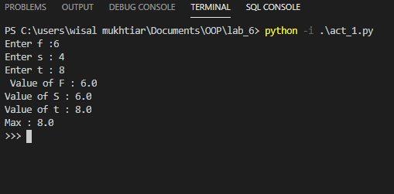

# Activity # 02

**Title:**

Make a class Base and Exponent and inherit class Power from Base and Exponent.

**IN C++**

**SOURCE CODE:**

#include <iostream>

using namespace std;

class Base

{

protected:

double ba;

void input_base()

{

cout<<"Enter base : ";

cin>>ba;

}

double show_base()

{

return ba;

}

};

class Exponent

{

protected:

double exp;

public:

void input_exp()

{

cout<<"Enter Exponent: ";

cin>>exp;

}

double show_exp()

{

return exp;

}

};

class Power: public Base, Exponent

{

protected:

int po;

public:

Power():po(1){}

public:

void in1()

{

input_base();

input_exp();

}

void show1()

{

cout<<"Base: "<<show_base()<<endl;

cout<<"Exponent: "<<show_exp()<<endl;

for(int i{0}; i<show_exp();i++)

{

po=po*show_base();

}

cout<<"Power = "<<po<<endl;

}

};

int main()

{

Power p1;

p1.in1();

p1.show1();

return 0;

}

**OBSERVATION (TESTING & DEBUGING):**

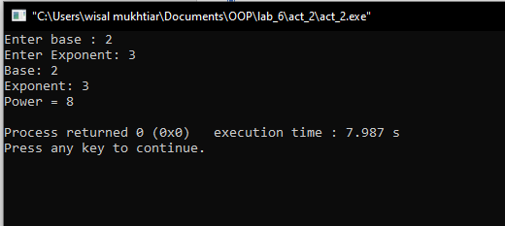

**In Python**

**Source code:**

from math import pow

class Base:

    ba = 0

    @classmethod

    def input_base(cls):

        Base.ba = float(input("Enter base : "))

    @classmethod

    def show_base(cls):

        return Base.ba

class Exponent:

    ex = 0

    @classmethod

    def input_expo(cls):

        Exponent.ex = float(input("Enter expo : "))

    @classmethod

    def show_expo(self):

        return Exponent.ex

class Power(Base, Exponent):

    Po = 0

    @classmethod

    def in1(cls):

        ba = Base.input_base()

        ex = Exponent.input_expo()

    @classmethod

    def show(cls):

        print(Base.show_base())

        print(Exponent.show_expo())

    @classmethod

    def calc_po(cls):

        Power.po = pow(Base.ba, Exponent.ex)

        print(f"Power is : {Power.po}")

p1 = Power()

p1.in1()

p1.show()

p1.calc_po()

**OBSERVATION (TESTING & DEBUGING):**

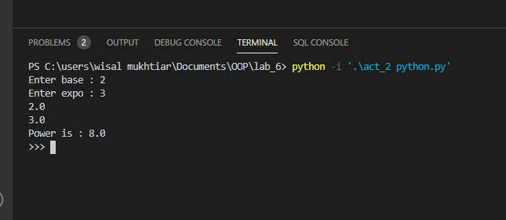

# Activity # 03

**Title:**

Redo Activity 1 and Activity 2 using multi-file Programming.

**Activity 2(Multi-File)(C++):**

**HEADER FILE (**classes.h)

#ifndef BASE_H_INCLUDED

#define BASE_H_INCLUDED

#include <iostream>

using namespace std;

class Base

{

protected:

double ba;

Public:

void input_base();

void show_base();

};

class Exponent

{

protected:

double exp;

public:

void input_exp();

void show_exp();

};

class Power: public Base, Exponent

{

protected:

int po;

public:

Power();

void in1();

void show1();

};

#endif

**Main File (main.cpp)**

#include <iostream>

#include <Classes.h>

using namespace std;

void Base:: input_base()

{

cout<<"Enter base : "<<endl;

cin>>ba;

}

double Base :: show_base()

{

return ba;

}

void Exponent :: input_exp()

{

cout<<"Enter Exponent: ";

cin>>exp;

}

double Exponent :: show_exp()

{

return exp;

}

Power :: Power():po(1){}

void Power :: in1()

{

input_base();

input_exp();

}

void Power :: show1()

{

cout<<"Base: "<<show_base()<<endl;

cout<<"Exponent: "<<show_exp()<<endl;

for(int i{0}; i<show_exp();i++)

{

po=po*show_base();

}

cout<<"Power = "<<po<<endl;

}

int main()

{

Power p1;

p1.in1();

p1.show1();

return 0;

}

**Activity 2 (Multi-file):**

**In Python**

**Source code:**

Main:

from classes import Third

t = Third()

t.input_t()

t.show()

t.max()

Classes:

class First:

    f = 0

    @classmethod

    def input_f(cls):

        First.f = float(input("Enter f :"))

class Second (First):

    s = 0

    @classmethod

    def input_s(cls):

        First.input_f()

        Second.s = float(input("Enter s : "))

class Third (Second):

    t = 0

    @classmethod

    def input_t(cls):

        Second.input_s()

        Third.t = float(input("Enter t : "))

    def show(self):

        print(f" Value of F : {First.f}\n"

        f"Value of S : {Second.f}\n"

        f"Value of t : {Third.t}")

    def max(self):

        max_no = max(Third.t, Second.s, First.f)

        print(f"Max : {max_no}")

**OBSERVATION (TESTING & DEBUGING):**

